GREATER CAIRO METRO
LINE No.3 (Thawra Line)
TCMS-VAC interface specification

Approved by | 26.Mar.2019 | K.K. SHIN | 
Reviewed by | 26.Mar.2019 | S.J. SEO | 
Written by | 26.Mar.2019 | H.KIM | 
 | Date | Name | Signature

Revision History
Issue | Page | Revision |  | Date
Issue | Page | Contents | Reference | Date
0 |  | First issue |  | 26.Mar.2019
1 |  | Modified by Carrier | By Mr. Lee,SK | 03.Apr.2019
2 |  | Modified by Carrier | By Mr. Lee,SK | 08.Jun.2019
3 |  | Modified by Carrier | By Mr. Lee,SK | 06.Aug.2019
4 |  | Port Address added for Cab MVB | By HRC, H.Kim | 21.Aug.2019

Contents
1. INTRODUCTION 4
1.1. LIST OF ABBREVIATIONS 4
2. GENERAL 5
2.1. MVB Specification 5
2.2. MVB Connection 6
2.3. MVB Telegram 6
2.4. Train Formation of Cairo3 8
3. DATA EXCHANGEG 9
3.1. TCMS → VAC SDR(Status Data Request) 9
3.1.1. Port Address 9
3.1.2. MVB Table 9
3.2. VAC → TCMS SD(Status Data) 11
3.2.1. Port Address 11
3.2.2. MVB Table 11

- INTRODUCTION
This document describes the interface specification between TCMS(Train Control and Monitoring System) and VAC(Ventilation Air conditioner Controller) for GREATER CAIRO METRO LINE No.3 (Thawra Line) project.
  - LIST OF ABBREVIATIONS
TCN Train Control Network
MVB Multifunction Vehicle Bus
EMD Electrical Medium Distance
WTB Wire Train Bus
TCMS Train Control and Monitoring System
CCU Central Control Unit
VCU Vehicle Control Unit
IO-M remote IO Module
VVVF Variable Voltage Variable Frequency
DU Display Unit
RTD Remote Transmission Device
DCU Door Control Unit
ATP Automatic Train Protection
EBCU Electrical Brake Control Unit
VAC Ventilation Air conditioner Controller
TCU Traction Control Unit
APU Auxiliary Power Unit
EVR Event Recorder
HCR Header Car Relay
MF Major Fault
MCF Major Complementary Fault
HSCB High Speed Circuit Breaker
LB Line Bus Switch
PB Parking Brake
EB Emergency Brake
HB Holding Brake
FSB Full Service Brake
AUTO Automatic Mode
ADB All Door Bypass
ADC All Door Closed
AAU Automatic Announcement Unit
DCU Display Control Unit(for PA/PIS)
BC Battery Charger
HCR Head Control Relay
SDR Status Data Request
SD Status Data

- GENERAL
  - MVB Specification
General specification of MVB is described as follow.
-. Redundancy : Line A, Line B
-. Master / Slave : TCMS is only Master.
The subsystem needs not to act as bus administrator.
-. Media Support : EMD(Electrical Middle Distance) Communication Distance within 200m

<Table 1 Summary of the Multifunction Vehicle Bus by IEC 61375-1>
topology | bus(electrical)  star(optical)
Media | Electrical Short Distance  Electrical Middle Distance  Optical Glass Fibre | twisted wire pair, biased RS-485  shielded twisted wire pair, transformer coupled  200/240 µm fibres and star coupler
Length | Electrical Short Distance  Electrical Middle Distance  Optical Glass Fibre | 20 m, 32 devices per segment  200 m, 32 devices per segment  2000 m
Physical Redundancy | duplicated physical medium(synchronous send)
Signalling | Manchester II, 9-bit frame Start Delimiter
Signalling rate | 1.5 Mbit/s
Address space | 12-bit Device Address  (0…255 reserved for devices with Message Data capability)  12-bit Logical Address for Process Data  (each 16…256 bits)
Physical Addressing | single cast and broadcast
Frame size  (useful data) | 16, 32, 64, 128, 256 bits
Integrity | CRC-8 per 64bits + Manchester encoding, different frame Start Delimiter for Master Frame and Slave Frame against synchronization slip, reception time window supervision
Medium Allocation | by one centralized Master(Hyundai-Rotem’s CCU & VCU)
Traffic | periodic(mainly for Process Data)  sporadic(mainly for Message Data)  supervisory(for Supervisory Data)
Mastership Transfer | mastership transfer by token passing  serveral Bus Administrators can become Master in turn
Mastership Redundancy  (Option) | redundant Bus Administrators serve as back-up
Link Layer Service | Link Process Data Interface  Link Message Data Interface  Link Supervision Interface | broadcast of source addressed data  datagrams  Link Layer Management

  - MVB Connection
Where interchangeability is required, Subsystems connected by MVB shall be attached to the cable as follow:
<Table 2 Pin assignment for the EMD Connector>
1 | A.Data_P positive wire of Line A | 6 | A.Term_P, Positive pole of Terminator Line A
2 | A.Data_N negative wire of Line A | 7 | A.Term_N, Negative pole of Terminator Line A
3 | Not Used | 8 | B.Term_P, Positive pole of Terminator Line B
4 | B.Data_P positive wire of Line B | 9 | B.Term_N, Negative pole of Terminator Line B
5 | B.Data_N negative wire of Line B
Note 1 It is recommend to arrange the two connectors side by side on a device, Connector 1 on the left and Connector 2 on the right, to thread the wiring neatly.
Note 2 It may be necessary to ensure that the connector case is isolated from the device case if connection of the device cases is not advisable, for instance when large stray currents are expected.
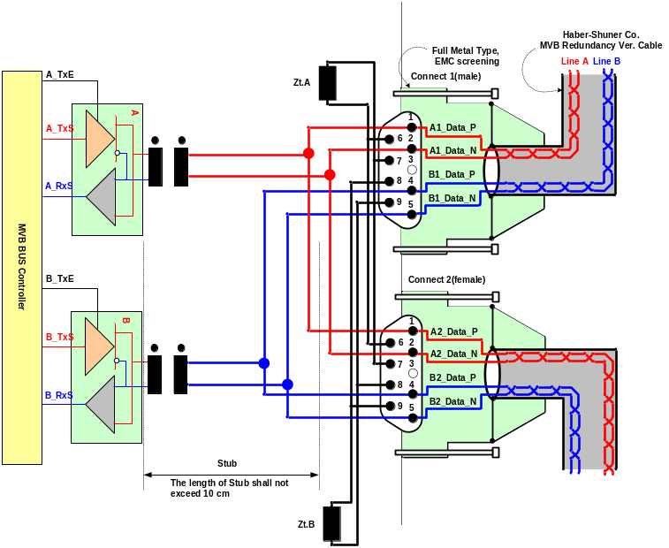
Figure 1 Double line EMD connector arrangement

  - MVB Telegram
There are 16 telegrams types on the MVB, which are distinguished by the F-code in Master Frame, as shown in Table 3.

Table 3 F-code of the MVB(Master Frame Type)
F-Code | Telegram Type
0 | Process Data Request with 16 bits
1 | Process Data Request with 32 bits
2 | Process Data Request with 64 bits
3 | Process Data Request with 128 bits
4 | Process Data Request with 256 bits
5 | (reserved)
6 | (reserved)
7 | (reserved)
8 | Mastership Transfer Request
9 | General Event Request
10 | (reserved)
11 | (reserved)
12 | Message Data Request
13 | Group Event Request
14 | Single Event Request
15 | Device Status Request
The basic data type for MVB network between TCMS and sub-system is WORD. Physical address is not used. The byte ordering is the Big-Endian(Motorola) but, all data is read like word. So, the subsystem side must change like example.
The byte order and bit order for a data are as follows.
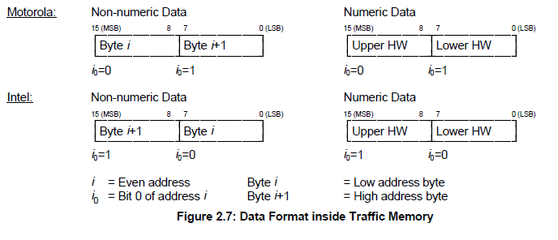
- MVB supervision :
The CCU is indicating the MVB state by the MVB watchdog counter that increases when the application is executed. The counter from the MVB device is generated as soon as the application software is ready. If no MVB connection is established, i.e. the MVB watchdog counter can not be received or an internal fault in the MVB device occurs, the signals, besides the watchdog counter, shall be had default value.

  - Train Formation of Cairo3
The train formation consists of 8 cars and can be seen in following figure. The detail arrangement is DTC-MC1-MC2-MCI-MCI-MC2-MC1-DTC. The two CCUs(Central Control Unit) are installed in both DTC, two VCUs are installed in MCI and two IO-Ms are installed in MC. CCU and VCU(Vehicle Control Unit) is connected to subsystem via MVB(Multifunction Vehicle Bus), WTB(Wire Train Bus) is used by the data communication interface between CCU and VCU.
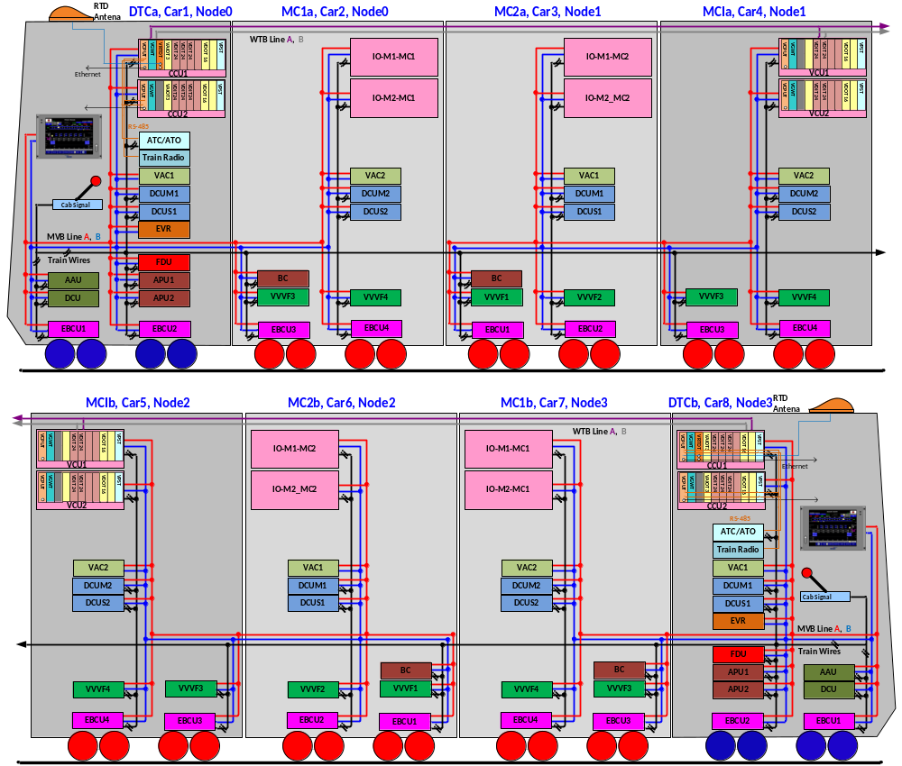

Figure 2 Configuration

- DATA EXCHANGEG

  - TCMS → VAC SDR(Status Data Request)
    - Port Address
Telegram name | Source | Sink | Port  address | Fcode | Task | Remark
TCMS-VAC1-SDR | TCMS | VAC 1 | 0xB8 | 3 | T3(64ms)
TCMS-VAC2-SDR | TCMS | VAC 2 | 0xBC | 3 | T3(64ms)

    - MVB Table
WORD | Data Contents
WORD | Bit Mask
WORD | 15 | 14 |  |  |  | 13 | 12 |  | 11 |  | 10 |  | 9 | 8
WORD | 7 | 6 |  |  |  | 5 | 4 |  | 3 |  | 2 |  | 1 | 0
0 | Watchdog Counter(0 – 65535), Life-sign  16-bits(WORD)
1 | Year(10), BCD |  |  |  |  |  |  |  | Year(1), BCD
1 | Month(10), BCD |  |  |  |  |  |  |  | Month(1), BCD
2 | Day(10), BCD |  |  |  |  |  |  |  | Day(1), BCD
2 | Hour(10), BCD |  |  |  |  |  |  |  | Hour(1), BCD
3 | Minute(10), BCD |  |  |  |  |  |  |  | Minute(1), BCD
3 | Sec(10), BCD |  |  |  |  |  |  |  | Sec(1), BCD
4 | Reference Return Air Temperature( Average Return Air temperature from all VACs in train)
4 | Car Number(DCT:0x1, MC1:0x2, MC2:0x03, MCI:0x04, MCI:0x05, MC2:0x06; MC1:0x07, DTC:0x08)
5 | Fire signal |  |  | Air compressor  Start signal | Power reduced  /Half load |  | MANUAL SET-POINT |  | VAC Control Command  0(0000) : Stop  1(0001) : VENT  2(0010) : COOL
5 | N/A |  | N/A |  | N/A |  | N/A | N/A |  | N/A |  | N/A |  |  | Emergency  Mode
6 | (현재 온도)Manual set-point value for Cooling Capacity Control (20℃~30℃, 1℃ unit)
6 | Adjust set-point value for UIC553 set-point (-5℃~5℃, 1℃ unit)
7 | FA  DAMPER  Close  Of  CAR 1 |  | FA  DAMPER  Close  Of  CAR 2 |  | FA  DAMPER  Close  Of  CAR 3 |  | FA  DAMPER  Close  Of  CAR 4 | FA  DAMPER  Close  Of  CAR 5 |  | FA  DAMPER  Close  Of  CAR 6 |  | FA  DAMPER  Close  Of  CAR 7 |  |  | FA  DAMPER  Close  Of  CAR 8
7 | RA  DAMPER  Close  Of  CAR 1 |  | RA  DAMPER  Close  Of  CAR 2 |  | RA  DAMPER  Close  Of  CAR 3 |  | RA  DAMPER  Close  Of  CAR 4 | RA  DAMPER  Close  Of  CAR 5 |  | RA  DAMPER  Close  Of  CAR 6 |  | RA  DAMPER  Close  Of  CAR 7 |  |  | RA  DAMPER  Close  Of  CAR 8

WORD 0
Watchdog Counter(Bit0 ~ Bit15) | -. VAC checks the health status of TCMS using this WC.  -. Range : 0 – 65535(Repeatedly)  -. TCMS count up +1 or more this WC in every cycle(T3(≤64ms)).  -. If this WC does not count up and remains previous value at least two seconds or more, it means the TCMS cut off or MVB failure.

WORD 1
Bit 0-  Bit 7 | Month | -. Month  -. Default Value : 0  -. 1 ~ 12
Bit 8-  Bit 15 | Year | -. Year  -. Default Value : 0  -. 0 ~ 99

WORD 2
Bit 0-  Bit 7 | Hour | -. Hour  -. Default Value : 0  -. 0 ~ 23
Bit 8  Bit 15 | Day | -. Day  -. Default Value : 0  -. 1 ~ 31

WORD 3
Bit 0  Bit 7 | Sec | -. Sec  -. Default Value : 0  -. 0 ~ 59
Bit 8  Bit 15 | Min | -. Min  -. Default Value : 0  -. 0 ~ 59

WORD 4
Bit 0  Bit 7 | Car Number | -. Car Number  -. Default Value : 1  -. 1 ~ 8
Bit 8  Bit 15 | Reference Room Temperature | -. Average Return Air temperature from all VACs in train  -. Default Value : 0  -.

WORD 5
Bit 0 | Emergency Mode | -. When vehicle state change to Emergency condition, this bit must be set to ‘1’.  -. Default value: 0  -. 0: Normal operation.  1: Emergency Mode
Bit 1  Bit 7 | N/A | -.  -. Default Value : 0  -.
Bit 8  Bit 11 | VAC Control Command | -. VAC Control Command  -. Default Value : 0  -. 0x0:STOP, 0x1: VENT, 0x2: COOL
Bit 12 | Manual Set-point | -. When Set-point does not controlled by UIC553, this bit must be set to ‘1’.  -. Default value: 0  -. 0: UIC553 Set-point value  1: Manual Set-point value
Bit 13 | Power reduced  /Half load | -. When vehicle state change to Power reduced condition, this bit must be set to ‘1’.  -. Default value: 0  -. 0: Normal operation.  1: Half load operation (Half cooling).

WORD 6
Bit 0  Bit 7 | Adjust set-point value for UIC553 set-point (-5℃~5℃, 1℃ unit) | -. Adjust Set-Point value of the Return Air temperature. This value is added to the Set-point determined by UIC553.  -. Default Value : 0  -. -5~5
Bit 8  Bit 15 | Manual set-point value for Cooling Capacity Control (20℃~30℃, 1℃ unit) | -. Manual Set-Point value of the Return Air temperature. In order to use this value, Manual Set-point (WORD5 bit12) must be set to '1 '.  -. Default Value : 23  -. 20~30

WORD 7
Bit 0 | FA Damper Close  Of CAR 8 | -. Fresh Air Damper Close Command.  -. Default Value : 0
Bit 1 | FA Damper Close  Of CAR 7 | -. Fresh Air Damper Close Command.  -. Default Value : 0
Bit 2 | FA Damper Close  Of CAR 6 | -. Fresh Air Damper Close Command.  -. Default Value : 0
Bit 3 | FA Damper Close  Of CAR 5 | -. Fresh Air Damper Close Command.  -. Default Value : 0
Bit 4 | FA Damper Close  Of CAR 4 | -. Fresh Air Damper Close Command.  -. Default Value : 0
Bit 5 | FA Damper Close  Of CAR 3 | -. Fresh Air Damper Close Command.  -. Default Value : 0
Bit 6 | FA Damper Close  Of CAR 2 | -. Fresh Air Damper Close Command.  -. Default Value : 0
Bit 7 | FA Damper Close  Of CAR 1 | -. Fresh Air Damper Close Command.  -. Default Value : 0
Bit 8 | RA Damper Close  Of CAR 8 | -. Return Air Damper Close Command.  -. Default Value : 0
Bit 9 | RA Damper Close  Of CAR 7 | -. Return Air Damper Close Command.  -. Default Value : 0
Bit 10 | RA Damper Close  Of CAR 6 | -. Return Air Damper Close Command.  -. Default Value : 0
Bit 11 | RA Damper Close  Of CAR 5 | -. Return Air Damper Close Command.  -. Default Value : 0
Bit 12 | RA Damper Close  Of CAR 4 | -. Return Air Damper Close Command.  -. Default Value : 0
Bit 13 | RA Damper Close  Of CAR 3 | -. Return Air Damper Close Command.  -. Default Value : 0  -.
Bit 14 | RA Damper Close  Of CAR 2 | -. Return Air Damper Close Command.  -. Default Value : 0
Bit 15 | RA Damper Close  Of CAR 1 | -. Return Air Damper Close Command.  -. Default Value : 0

  - VAC → TCMS SD(Status Data)
    - Port Address
Telegram name | Source | Sink | Port  address | Fcode | Task | Remark
VAC1-TCMS-SD | VAC1 | TCMS | B0H | 4 | T3(64ms)
VAC2-TCMS-SD | VAC2 | TCMS | B4H | 4 | T3(64ms)
    - MVB Table
WORD | Data Contents
WORD | Bit Mask
WORD | 15 | 14 |  |  | 13 | 12 | 11 |  | 10 | 9 | 8
WORD | 7 | 6 |  |  | 5 | 4 | 3 |  | 2 | 1 | 0
0 | Watchdog Counter(0 – 65535), Life-sign  16-bits(WORD)
1 | VAC Software Ver No. X0.00(BCD) |  |  |  |  |  | VAC Software Ver No. 0X.00(BCD)
1 | VAC Software Ver No. 00.X0(BCD) |  |  |  |  |  | VAC Software Ver No. 00.0X(BCD)
2 |  |  |  |  |  |  | SPARE | SPARE |  | SPARE |  | Main Power Status  (AC Power)
2 | UNIT2  STOP  INVERTER RUN |  | UNIT1  STOP | UNIT2  EVAP OP.  COMP2  OP. |  | UNIT1  EVAP OP.  COMP 1  OP. | UNIT2  CYCLE2 OP.  COND Low Speed OP. | UNIT2  CYCLE1 OP.  COND High Speed OP. |  | UNIT1  CYCLE2 OP.  EVAP 2  OP. |  | UNIT1  CYCLE1 OP.  EVAP1, 3  OP.
3 | UNIT1  COND2 Fault |  | UNIT1  COND1 Fault | UNIT1  COMP2 Fault  COMP 2  Fault |  | UNIT1  CYCLE2 LP  COMP 1  Fault | UNIT1  CYCLE2 HP | UNIT1  COMP1 Fault  COND  Fault |  | UNIT1  CYCLE1 LP  EVAP 2  Fault |  | UNIT1  CYCLE1 HP  EVAP1,3 Fault
3 | UNIT2  COND2 Fault |  | UNIT2  COND1 Fault | UNIT2  COMP2 Fault |  | UNIT2  CYCLE2 LP  INVERTER Fault | UNIT2  CYCLE2 HP  CYCLE2 LP | UNIT2  COMP1 Fault  CYCLE2 HP |  | UNIT2  CYCLE1 LP  CYCLE1 LP |  | UNIT2  CYCLE1 HP  CYCLE1 HP
4 | N/A |  | N/A | N/A |  | N/A | N/A | N/A |  | UNIT2  EVAP Fault |  | UNIT1  EVAP Fault
4 | VAC Set-point value (20℃~30℃)
5 | Fresh Air Temperature value (-25℃~80℃) 실내
5 | Return Air Temperature value (-25℃~80℃) 실외
6 | UNIT1 Fresh Air Temperature value (-25℃~80℃)
6 | UNIT2 Fresh Air Temperature value (-25℃~80℃)
7
8
9
10
11
12
13
14
15

WORD 0
Watchdog Counter(Bit0 ~ Bit15) | -. TCMS checks the health status of VAC using this WC.  -. Range : 0 – 65535(Repeatedly)  -. VAC count up +1 or more this WC in every cycle(T3(≤64ms)).  -. If this WC does not count up and remains previous value at least two seconds or more, it means the VAC cut off or MVB failure.

WORD 1
Bit0~Bit3 | Software Version | -. VAC Controller Software Version  -. Default 0  -. 0 ~ 9
Bit4~Bit7 | Software Version | -. VAC Controller Software Version  -. Default 0  -. 0 ~ 9
Bit8~Bit11 | Software Version | -. VAC Controller Software Version  -. Default 0  -. 0 ~ 9
Bit12  ~Bit15 | Software Version | -. VAC Controller Software Version  -. Default 0  -. 0 ~ 9

WORD 2
Bit 0 | EVAP 1,3 OP. | -. Operating Status of VAC EVAP 1, EVAP 3  -. Default 0  -. 0,1
Bit 1 | EVAP 2 OP. | -. Operating Status of VAC EVAP 2  -. Default 0  -. 0,1
Bit 2 | COND High Speed OP. | -. Operating Status of VAC COND High Speed  -. Default 0  -. 0,1
Bit 3 | COND Low Speed OP. | -. Operating Status of VAC COND Low Speed  -. Default 0  -. 0,1
Bit 4 | COMP1 OP. | -. Operating Status of VAC COMP1  -. Default 0  -. 0,1
Bit 5 | COMP2 OP. | -. Operating Status of VAC COMP2  -. Default 0  -. 0,1

Bit 6
Bit 7 | INVERTER RUN | -. When Inverter run signal source is run to all EVAP Fan  -. Default 0  -. 0: VAC Unit2 Running, 1: VAC Unit2 STOP
Bit 8 | Main Power Status | -. When power source (380V) is supplied to VAC distribution board, this bit is set to ‘1’.  -. Default 0  -. 0,1
Bit 9 | Fire Detection Signal | -. When Fire Detection Signal is transferred to VAC distribution board, this bit is set to ‘1’.  -. Default Value : 0  -. 0 ~ 1
Bit 10 | N/A | -.  -. Default Value : 0  -.
Bit 11 | N/A | -.  -. Default Value : 0  -.

WORD 3
Bit 0 | EVAP1,3 Fault | -. If overload fault occurred in Evaporator Fan1,3, this bit is set to ‘1’  -. Default Value : 0  -. 0 ~ 1
Bit 1 | EVAP 2 Fault | -. If overload fault occurred in Evaporator Fan2, this bit is set to ‘1’  -. Default Value : 0  -. 0 ~ 1
Bit 2 | COND Fault | -. If overload fault occurred in Condenser Fan, this bit is set to ‘1’  -. Default Value : 0  -. 0 ~ 1

Bit 3
Bit 4 | COMP1 Fault | -. If overload fault occurred in Compressor1, this bit is set to ‘1’  -. Default Value : 0  -. 0 ~ 1
Bit 5 | COMP2 Fault | -. If overload fault occurred in Compressor2, this bit is set to ‘1’  -. Default Value : 0  -. 0 ~ 1

Bit 6

Bit 7
Bit 8 | CYCLE1 HP | -. If high-pressure occurred in Cycle1, this bit is set to ‘1’  -. Default Value : 0  -. 0 ~ 1
Bit 9 | CYCLE1 LP | -. If low-pressure occurred in Cycle1, this bit is set to ‘1’  -. Default Value : 0  -. 0 ~ 1
Bit 10 | CYCLE2 HP | -. If high-pressure occurred in Cycle2, this bit is set to ‘1’  -. Default Value : 0  -. 0 ~ 1
Bit 11 | CYCLE2 LP | -. If low-pressure occurred in Cycle2, this bit is set to ‘1’  -. Default Value : 0  -. 0 ~ 1
Bit 12 | INERTER Fault | -. If some fault occurred in Inverter, this bit is set to ‘1’  -. Default Value : 0  -. 0 ~ 1

Bit 13

Bit 14

Bit 15

WORD 4
Bit0~  Bit7 | VAC Set-point value  (20℃~30℃) | -. Set point value that used VAC control. This value is determined by UIC553 or manual (depend on SDR data word 5 bit12)  -. Default 23  -. 20 ~ 30
Bit8 | UNIT1 EVAP Fault | -. If overload fault occurred in Unit1 Evaporator Fan, this bit is set to ‘1’  -. Default Value : 0  -. 0 ~ 1
Bit9 | UNIT2 EVAP Fault | -. If overload fault occurred in Unit1 Evaporator Fan2, this bit is set to ‘1’  -. Default Value : 0  -. 0 ~ 1

WORD 5
Bit0~  Bit7 | Return Air  Temperature Value | -. Return Air Temperature Value.  -. Default 0  -. -25 ~ +80
Bit8~  Bit15 | Fresh Air  Temperature Value | -. Fresh Air Temperature Value.  -. Default 0  -. -25 ~ +80

WORD 6
Bit0~  Bit7 | Unit2 Fresh Air  Temperature Value | -. Unit2 Fresh Air Temperature Value.  -. Default 0  -. -25 ~ +80
Bit8~  Bit15 | Unit1 Fresh Air  Temperature Value | -. Unit1 Fresh Air Temperature Value.  -. Default 0  -. -25 ~ +80

  - TCMS → CAB VAC SDR(Status Data Request)
    - Port Address
Telegram name | Source | Sink | Port  address | Fcode | Task | Remark
TCMS-VAC1-SDR | TCMS | CAB VAC | 0xA8 | 3 | T3(64ms)

    - MVB Table
WORD | Data Contents
WORD | Bit Mask
WORD | 15 | 14 |  |  |  | 13 | 12 | 11 |  | 10 |  | 9 | 8
WORD | 7 | 6 |  |  |  | 5 | 4 | 3 |  | 2 |  | 1 | 0
0 | Watchdog Counter(0 – 65535), Life-sign  16-bits(WORD)
1 | Year(10), BCD |  |  |  |  |  |  | Year(1), BCD
1 | Month(10), BCD |  |  |  |  |  |  | Month(1), BCD
2 | Day(10), BCD |  |  |  |  |  |  | Day(1), BCD
2 | Hour(10), BCD |  |  |  |  |  |  | Hour(1), BCD
3 | Minute(10), BCD |  |  |  |  |  |  | Minute(1), BCD
3 | Sec(10), BCD |  |  |  |  |  |  | Sec(1), BCD
4 | N/A
4 | N/A
5 | N/A |  |  | N/A | N/A |  | MANUAL SET-POINT | N/A
5 | N/A |  | N/A |  | N/A |  | N/A | N/A | FA  DAMPER  Close |  | RA  DAMPER  Close |  |  | Emergency  Mode
6 | Manual set-point value for Cooling Capacity Control (20℃~30℃, 1℃ unit)
6 | Adjust set-point value for UIC553 set-point (-5℃~5℃, 1℃ unit)

WORD 0
Watchdog Counter(Bit0 ~ Bit15) | -. VAC checks the health status of TCMS using this WC.  -. Range : 0 – 65535(Repeatedly)  -. TCMS count up +1 or more this WC in every cycle(T3(≤64ms)).  -. If this WC does not count up and remains previous value at least two seconds or more, it means the TCMS cut off or MVB failure.

WORD 1
Bit 0-  Bit 7 | Month | -. Month  -. Default Value : 0  -. 1 ~ 12
Bit 8-  Bit 15 | Year | -. Year  -. Default Value : 0  -. 0 ~ 99

WORD 2
Bit 0-  Bit 7 | Hour | -. Hour  -. Default Value : 0  -. 0 ~ 23
Bit 8  Bit 15 | Day | -. Day  -. Default Value : 0  -. 1 ~ 31

WORD 3
Bit 0  Bit 7 | Sec | -. Sec  -. Default Value : 0  -. 0 ~ 59
Bit 8  Bit 15 | Min | -. Min  -. Default Value : 0  -. 0 ~ 59

WORD 5
Bit 0 | Emergency Mode | -. When vehicle state change to Emergency condition, this bit must be set to ‘1’.  -. Default value: 0  -. 0: Normal operation.  1: Emergency Mode
Bit 1 | RA Damper Close  Of CAR 5 | -. Return Air Damper Close Command.  -. Default Value : 0
Bit 2 | FA Damper Close  Of CAR 8 | -. Fresh Air Damper Close Command.  -. Default Value : 0
Bit 3  Bit 11 | N/A | -.  -. Default Value : 0  -.
Bit 12 | Manual Set-point | -. When Set-point does not controlled by UIC553, this bit must be set to ‘1’.  -. Default value: 0  -. 0: UIC553 Set-point value  1: Manual Set-point value
Bit 13  Bit 15 | N/A | -.  -. Default Value : 0  -.

WORD 6
Bit 0  Bit 7 | Adjust set-point value for UIC553 set-point (-5℃~5℃, 1℃ unit) | -. Adjust Set-Point value of the Return Air temperature. This value is added to the Set-point determined by UIC553.  -. Default Value : 0  -. -5~5
Bit 8  Bit 15 | Manual set-point value for Cooling Capacity Control (20℃~30℃, 1℃ unit) | -. Manual Set-Point value of the Return Air temperature. In order to use this value, Manual Set-point (WORD5 bit12) must be set to '1 '.  -. Default Value : 23  -. 20~30

  - CAB VAC → TCMS SD(Status Data)
    - Port Address
Telegram name | Source | Sink | Port  address | Fcode | Task | Remark
CAB VAC-TCMS-SD | CAB VAC | TCMS | 0xA4 | 4 | T3(64ms)
    - MVB Table
WORD | Data Contents
WORD | Bit Mask
WORD | 15 | 14 |  |  | 13 | 12 | 11 |  | 10 | 9 | 8
WORD | 7 | 6 |  |  | 5 | 4 | 3 |  | 2 | 1 | 0
0 | Watchdog Counter(0 – 65535), Life-sign  16-bits(WORD)
1 | VAC Software Ver No. X0.00(BCD) |  |  |  |  |  | VAC Software Ver No. 0X.00(BCD)
1 | VAC Software Ver No. 00.X0(BCD) |  |  |  |  |  | VAC Software Ver No. 00.0X(BCD)
2 | N/A |  |  | N/A |  |  | SPARE | SPARE |  | SPARE |  | Main Power Status  (AC Power)
2 | N/A |  |  | N/A
2 | N/A |  | UNIT  STOP | N/A |  | UNIT  EVAP OP. | N/A | N/A |  | N/A |  | UNIT  CYCLE OP.
3 | UNIT  EVAP Fault |  | UNIT  COND Fault | N/A |  | N/A | N/A | UNIT  COMP Fault |  | UNIT  CYCLE LP |  | UNIT  CYCLE HP
3 | N/A |  | N/A | N/A |  | N/A | N/A | N/A |  | N/A |  | N/A
4 | N/A |  | N/A | N/A |  | N/A | N/A | N/A |  | N/A |  | N/A
4 | VAC Set-point value (20℃~30℃)
5 | Return Air Temperature value (-25℃~80℃)
5 | N/A
6 | Fresh Air Temperature value (-25℃~80℃)
6 | N/A

WORD 0
Watchdog Counter(Bit0 ~ Bit15) | -. TCMS checks the health status of VAC using this WC.  -. Range : 0 – 65535(Repeatedly)  -. VAC count up +1 or more this WC in every cycle(T3(≤64ms)).  -. If this WC does not count up and remains previous value at least two seconds or more, it means the VAC cut off or MVB failure.

WORD 1
Bit0~Bit3 | Software Version | -. VAC Controller Software Version  -. Default 0  -. 0 ~ 9
Bit4~Bit7 | Software Version | -. VAC Controller Software Version  -. Default 0  -. 0 ~ 9
Bit8~Bit11 | Software Version | -. VAC Controller Software Version  -. Default 0  -. 0 ~ 9
Bit12  ~Bit15 | Software Version | -. VAC Controller Software Version  -. Default 0  -. 0 ~ 9

WORD 2
Bit 0 | UNIT CYCLE1 OP. | -. Operating Status of VAC Cycle  -. Default 0  -. 0,1
Bit 1 | N/A | -.  -. Default Value : 0  -.
Bit 2 | N/A | -.  -. Default Value : 0  -.
Bit 3 | N/A | -.  -. Default Value : 0  -.
Bit 4 | UNIT EVAP OP. | -. Operating Status of VAC Unit Evaporator FAN  -. Default 0  -. 0,1
Bit 5 | N/A | -.  -. Default Value : 0  -.
Bit 6 | UNIT STOP | -. STOP Status of VAC Unit  -. Default 0  -. 0: Unit1 VAC Running, 1: Unit VAC STOP
Bit 7 | N/A | -.  -. Default Value : 0  -.
Bit 8 | Main Power Status | -. When power source (380V) is supplied to VAC distribution board, this bit is set to ‘1’.  -. Default 0  -. 0,1
Bit 9  Bit 15 | N/A | -.  -. Default Value : 0  -.

WORD 3
Bit 0  Bit 7 | N/A | -.  -. Default Value : 0  -.
Bit 8 | UNIT CYCLE HP | -. If high-pressure occurred in Unit Cycle, this bit is set to ‘1’  -. Default Value : 0  -. 0 ~ 1
Bit 9 | UNIT CYCLE LP | -. If low-pressure occurred in Unit Cycle, this bit is set to ‘1’  -. Default Value : 0  -. 0 ~ 1
Bit 10 | UNIT COMP Fault | -. If overload fault occurred in Unit Compressor, this bit is set to ‘1’  -. Default Value : 0  -. 0 ~ 1
Bit 11 | N/A | -.  -. Default Value : 0  -.
Bit 14 | UNIT COND Fault | -. If overload fault occurred in Unit Condenser Fan, this bit is set to ‘1’  -. Default Value : 0  -. 0 ~ 1
Bit 15 | UNIT EVAP Fault | -. If overload fault occurred in Unit Evaporator Fan, this bit is set to ‘1’  -. Default Value : 0  -. 0 ~ 1

WORD 4
Bit0~  Bit7 | VAC Set-point value  (20℃~30℃) | -. Set point value that used VAC control. This value is determined by UIC553 or manual (depend on SDR data word 5 bit12)  -. Default 23  -. 20 ~ 30

WORD 5
Bit0~  Bit7 | N/A | -.  -. Default Value : 0  -.
Bit8~  Bit15 | Unit Return Air  Temperature Value | -. Unit Return Air Temperature Value.  -. Default 0  -. -25 ~ +80

WORD 6
Bit0~  Bit7 | N/A | -.  -. Default Value : 0  -.
Bit8~  Bit15 | Unit Fresh Air  Temperature Value | -. Unit Fresh Air Temperature Value.  -. Default 0  -. -25 ~ +80

